Date: 25/11/2025 | Class: 10Evansville
C4.2.2 Extracting Less Reactive Metals

Big picture (Medium term plan, national curriculum, responding to formative data):

MTP: This lesson is the second lesson on C4.2, also a slight recap on year 9, it will help them recap how to write word equations as well as balance equations.

National curriculum (AQA):

- “When metals react with other substances the metal atoms form positive ions.”
- “The reactivity of a metal is related to its tendency to form positive ions.”
- “Metals can be arranged in order of their reactivity in a reactivity series.”
- “The metals potassium, sodium, lithium, calcium, magnesium, zinc, iron and copper can be put in order of reactivity from their reactions with water and dilute acids.”
- “A more reactive metal can displace a less reactive metal from a compound.”
Completed independent task/You (including annotated thinking process):

Think Aloud script:
- First, I’m looking at the sheet and I see we’re working with reactions involving metal oxides and carbon. Before I even start writing, I ask myself, what do I already know about this? I know oxidation and reduction have to do with oxygen being gained or lost.

- “Now I look at the first example. It says the copper has lost oxygen. I think losing oxygen… hmmm I remember from earlier that it means reduction. So I fill that in.”
- “Then it mentions carbon gaining oxygen. I ask myself, If losing oxygen is reduction, then gaining oxygen must be oxidation. So that helps me answer that part.”

- “moving down to the word equations, I notice a pattern. Every example seems to show:
metal oxide + carbon → metal + carbon dioxide.
So I’m using that pattern to help me predict the answers for the ones I have to finish.”

- “When the sheet asks for observations, I think: What would I actually see in a reaction like this? Maybe colour changes, maybe the metal appearing, maybe gas being released.”
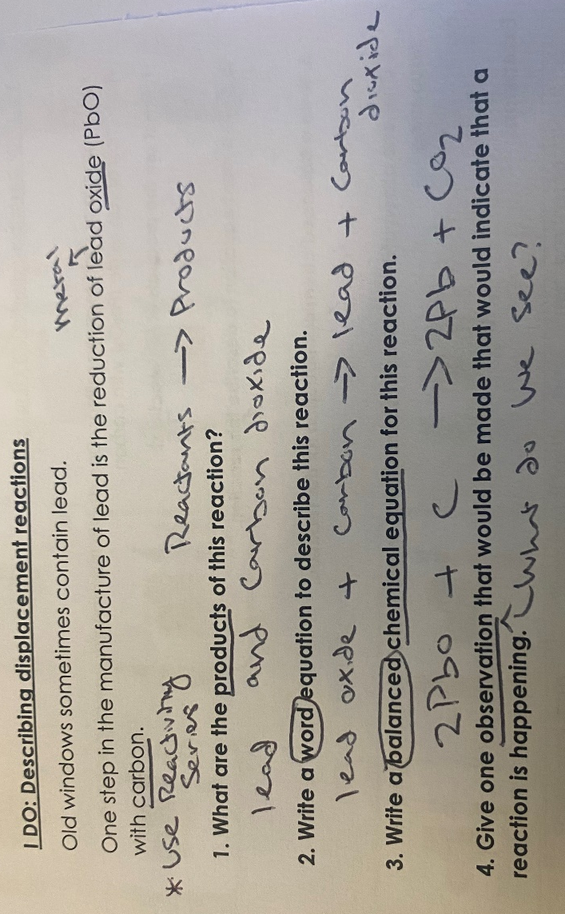
- “When I get to the balanced equations, I’m reminding myself to count atoms. I’m thinking aloud: Okay, how many oxygens here? (either under visualiser or on the board) How many carbon atoms there? I need the same number on both sides. Even if I’m not sure, I try to match what I see in the example.”
- “If something looks confusing and I think I’m not sure about this part yet, but I’ll use the examples and go step by step.”

Misconceptions to be aware of:

- Mixing up the definitions: (thinking reduction = loss of electrons rather than gain of oxygen)
- Forgetting that both oxidation and reduction happen together in a displacement reaction.
- Not recognising that the metal oxide is what gets reduced, not the metal itself.
- Confusing oxidising agent and reducing agent.
TKT & TBAT:

TKT: A reactivity series lists metals from most to least reactive.
TKT: A displacement reaction occurs when a more reactive metal replaces a less reactive metal in a compound.
TKT: Oxidation = gain of oxygen; Reduction = loss of oxygen.
TKT: Carbon can extract metals less reactive than carbon from their oxides.
TKT: In a displacement reaction, the more reactive metal is oxidised and the less reactive metal is reduced.

TBAT: List metals in order of reactivity.
TBAT: Describe what you would observe when metals of different reactivities react with hydrochloric acid.
TBAT: Write word equations for displacement reactions and predict products.
TBAT: State products for metal oxide + carbon reactions.
TBAT: Identify which substances are oxidised and reduced in displacement reactions.
TBAT: Write definitions for oxidation and reduction.
TBAT: State what is oxidised in ZnO + C and what is reduced.

# of I, We, CfU, You cycles:
I DO
- I’ll show them how to read a reactivity series and just talk through my thinking, like “okay, this one is higher up so it’s more reactive.”
- I explain how I know if a displacement reaction will happen.
- I model the oxidation/reduction definitions — I probs repeat them a couple times out loud.
- I write a word equation and talk through it slowly.
WE DO
- We work together to decide which metal is more reactive.
- As a class we try predicting if a reaction happens or not.
- We write part of a word equation together.
- Students help me work out which one’s oxidised and which one’s reduced (with hints if they get stuck).
CfU (Check for Understanding)
- Quick Qs like: “Which metal’s more reactive here?”
- “Will this displacement reaction actually happen?”
- “What does reduction mean again?”
- Use mini whiteboards to ensure all students understand

Lesson part | TKT/  TBAT | Description (inc. scripting and use of other adults where appropriate) | Time
Do Now |  | “You have 5 minutes to read the read now and answer the five questions in full sentences” “please make sure your read now is stuck in in 5,4…) | 5
Hook |  | How can a rock be used in making an iPhone?
Intro (introduce, sequence,  importance, enthuse) |  | Introduce:  Sequence: We recapped reactivity last lesson; today we apply it to displacement and metal extraction.  Importance/ enthuse: This is the chemistry that turns ordinary rocks into shiny, useful metals it’s basically the chemistry that lets us turn dull rocks into the metals that build phones. | 1
I |  | I will show them how to decide if something was oxidized or reduced, after showing an example (probably 2).
We |  | Class completes the fill in the gaps.  We (Guided Practice)  - Students help complete the next displacement equation (e.g., lead oxide + carbon, tin oxide + carbon).  - Guided questions:  - “Which metal is more reactive?”  - “Who gets oxidised? Who gets reduced?”  - “What observation would you expect?”
CfU |  | Cold call + mini whiteboards:  - “Write the products of copper oxide + carbon.”  - “State which substance has been oxidised.”  - “Explain why gold does not react with acids.”  Address misconceptions immediately.
You |  | Repeats of I, WE YOU, refer to worksheet  Students complete:  - Ordering metals by reactivity.  - Predicting products of displacement reactions.  - Writing word equations for: copper oxide + carbon, tin oxide + carbon.  - Identifying oxidised and reduced species in ZnO + C, PbO + C, CuO + C.
Exit Ticket |  | 1. Which answer correctly describes the reaction between lithium and aluminium oxide?  a. lithium + aluminium oxide -> lithium aluminium + oxygen  b. Lithium + aluminium oxide -> lithium oxide + aluminium  c. lithium and aluminium oxide would not react  2. Which of the metals below would be found as a pure metal in the Earth's crust?  a. Aluminium  b. Gold  c. Copper oxide (An ore)  3. The combustion of magnesium can be represented by the following equation: 2Mg + O2 -> 2MgO. What type of reaction is this?  a. A reduction reaction  b. An oxidation reaction  c. A neutralisation reaction
Homework |  | N/A (will be collecting in homework)
Resources needed |  | Worksheet (exposition/worksheet)  Read Now  Slides  Mini whiteboard

